Manual Técnico

**NurseBot**

Diagrama de red

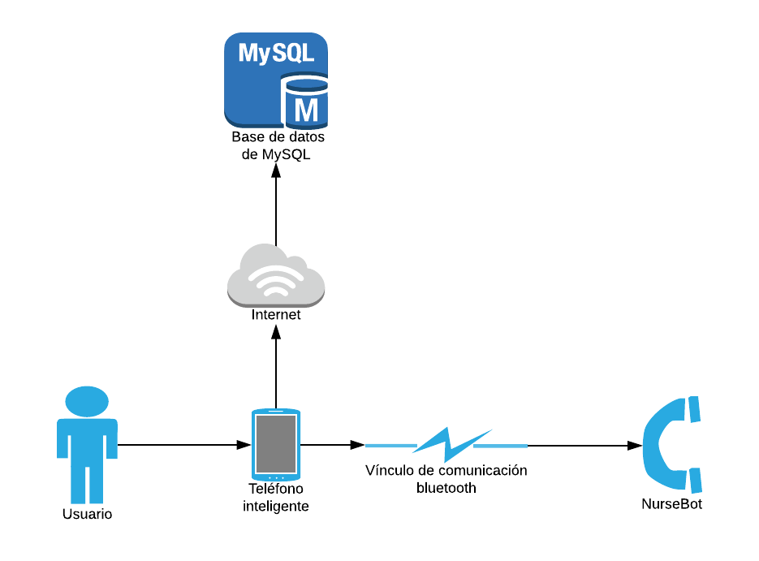

Diagrama de despliegue del sistema

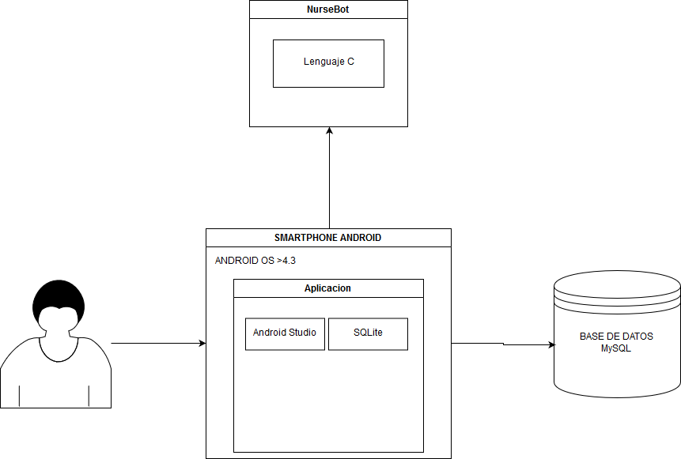

Modelo entidad relación de la base de datos

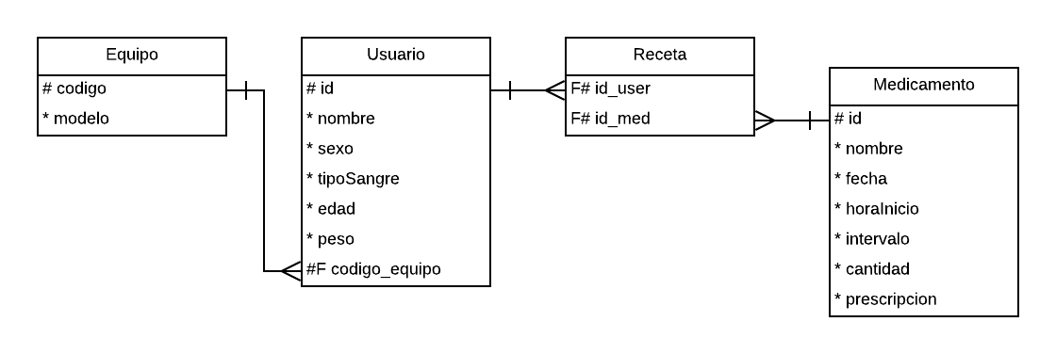

Configuración de los dispositivos utilizados

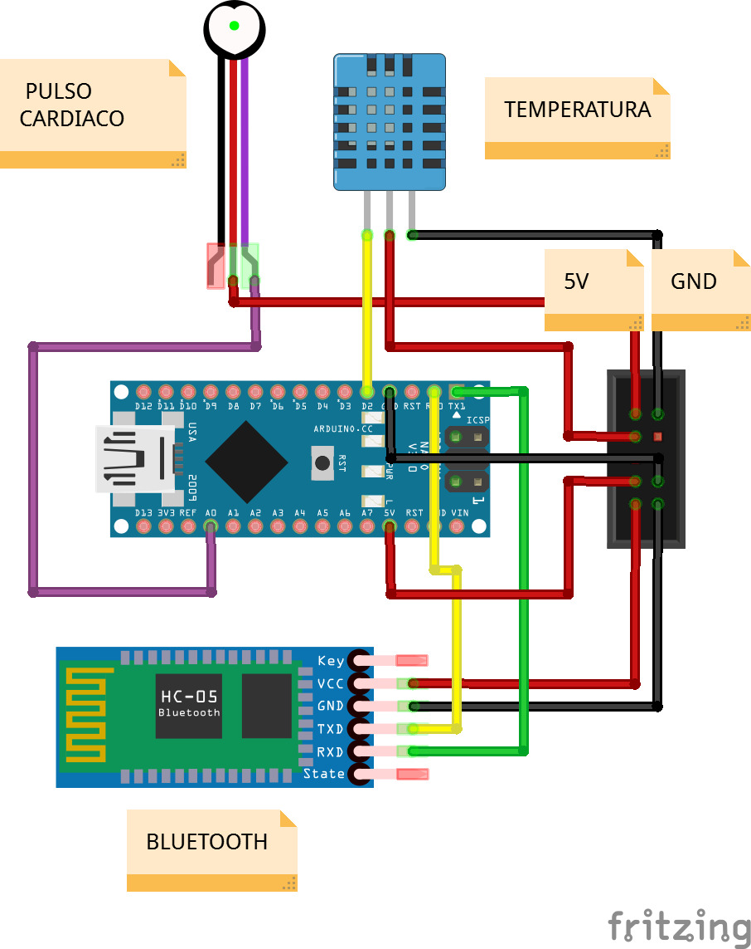

Código fuente Arduino

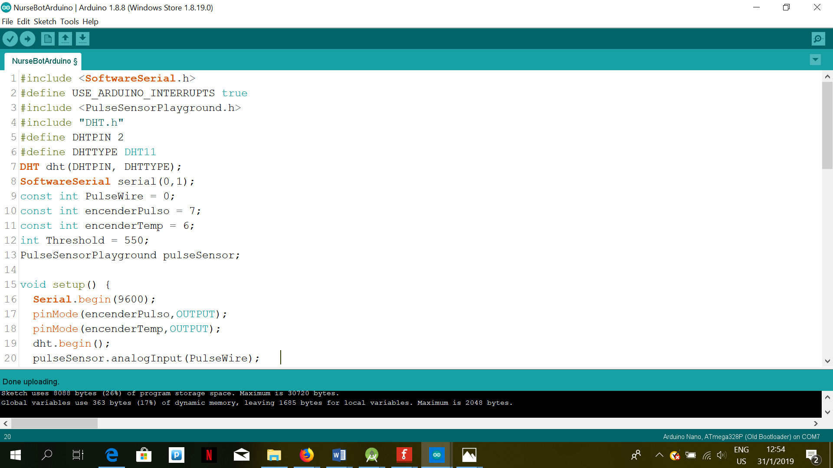

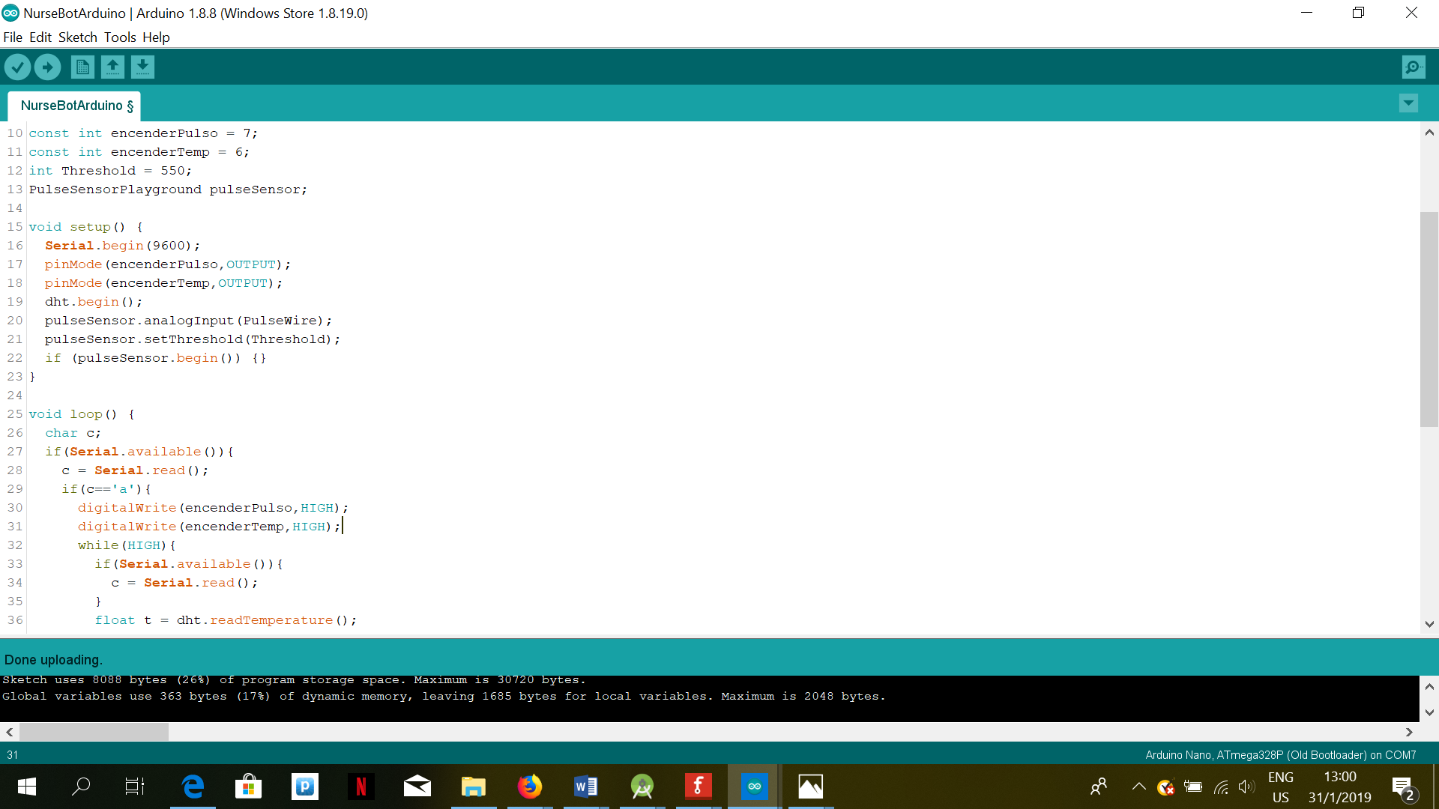

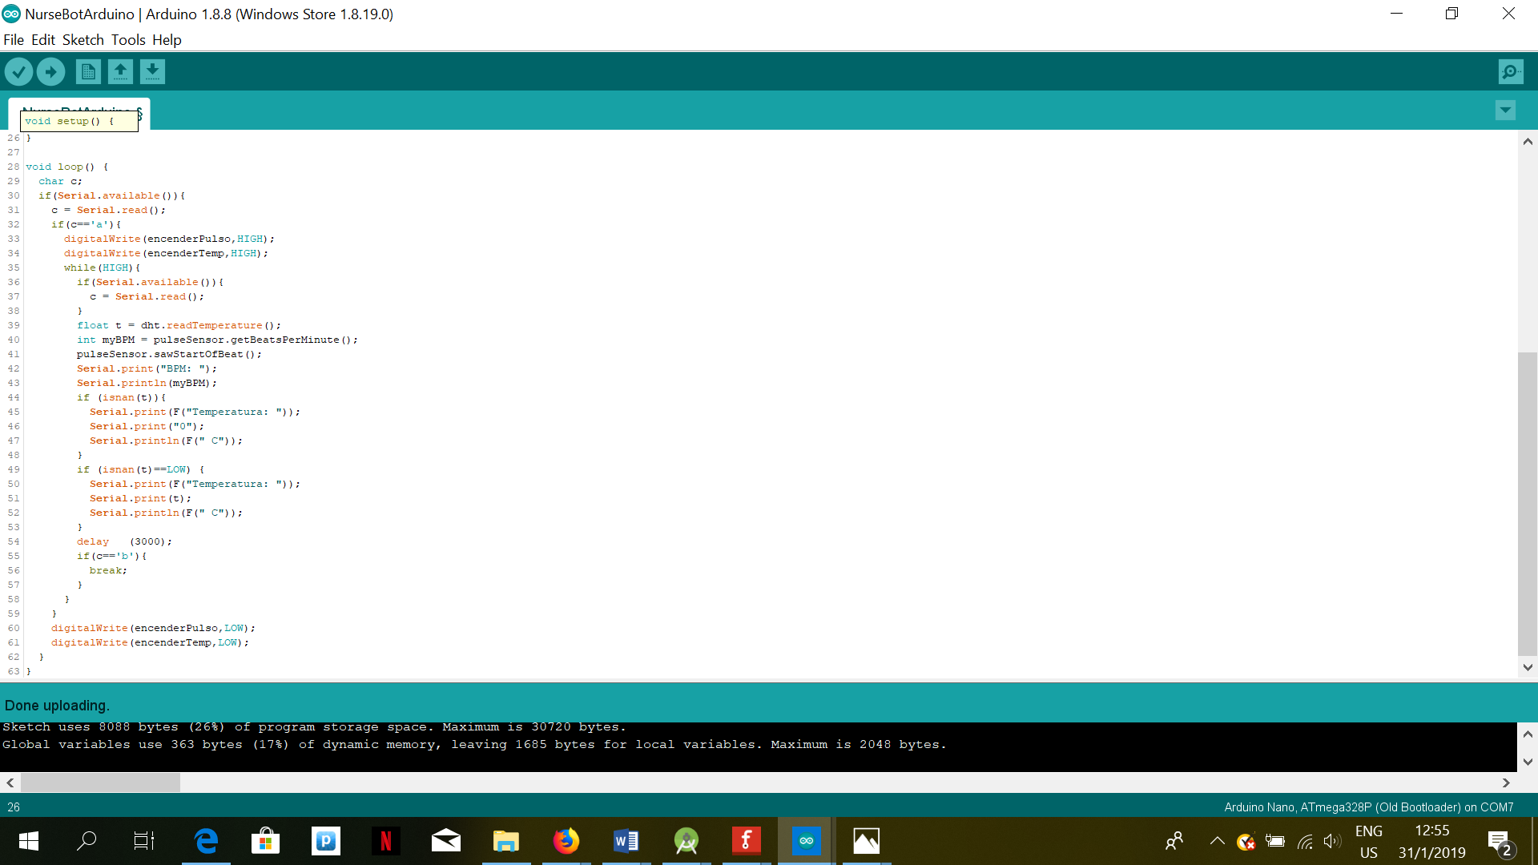

Código fuente Android Studio

Activity LogIn

package com.example.nursebotpst;  
  
import android.app.Activity;  
import android.content.Intent;  
import android.support.v7.app.AppCompatActivity;  
import android.os.Bundle;  
import android.view.View;  
  
public class LogIn extends AppCompatActivity {  
  
 @Override  
 protected void onCreate(Bundle savedInstanceState) {  
 super.onCreate(savedInstanceState);  
 setContentView(R.layout.activity_log_in);  
 }  
  
 public void iniciar(View v){  
 Intent i = new Intent(this, MainActivity.class);  
 startActivity(i);  
 finish();  
 }  
  
 public void registrar(View v){  
 Intent i = new Intent(this, SignIn.class);  
 startActivity(i);  
 }  
}

Activity Menu

package com.example.nursebotpst;  
  
import android.content.Intent;  
import android.support.v7.app.AppCompatActivity;  
import android.os.Bundle;  
import android.view.View;  
  
public class MainActivity extends AppCompatActivity {  
  
 @Override  
 protected void onCreate(Bundle savedInstanceState) {  
 super.onCreate(savedInstanceState);  
 setContentView(R.layout.activity_main);  
 }  
  
  
 public void medicion(View view) {  
 Intent i = new Intent(this, MedActivity.class);  
 startActivity(i);  
 }  
  
  
  
 public void cronograma(View v){  
 Intent i = new Intent(this, Cronograma.class);  
 startActivity(i);  
 }  
  
 public void medicamento(View v){  
 Intent i = new Intent(this, Medicamento.class);  
 startActivity(i);  
 }  
}

Activity Medicion

package com.example.nursebotpst;  
  
import android.content.Intent;  
import android.support.v7.app.AppCompatActivity;  
import android.os.Bundle;  
import android.view.View;  
  
public class MainActivity extends AppCompatActivity {  
  
 @Override  
 protected void onCreate(Bundle savedInstanceState) {  
 super.onCreate(savedInstanceState);  
 setContentView(R.layout.activity_main);  
 }  
  
  
 public void medicion(View view) {  
 Intent i = new Intent(this, MedActivity.class);  
 startActivity(i);  
 }  
  
  
  
 public void cronograma(View v){  
 Intent i = new Intent(this, Cronograma.class);  
 startActivity(i);  
 }  
  
 public void medicamento(View v){  
 Intent i = new Intent(this, Medicamento.class);  
 startActivity(i);  
 }  
}

Activity Medicamento

package com.example.nursebotpst;  
  
import android.content.Intent;  
import android.support.v7.app.AppCompatActivity;  
import android.os.Bundle;  
import android.view.View;  
  
public class MainActivity extends AppCompatActivity {  
  
 @Override  
 protected void onCreate(Bundle savedInstanceState) {  
 super.onCreate(savedInstanceState);  
 setContentView(R.layout.activity_main);  
 }  
  
  
 public void medicion(View view) {  
 Intent i = new Intent(this, MedActivity.class);  
 startActivity(i);  
 }  
  
  
  
 public void cronograma(View v){  
 Intent i = new Intent(this, Cronograma.class);  
 startActivity(i);  
 }  
  
 public void medicamento(View v){  
 Intent i = new Intent(this, Medicamento.class);  
 startActivity(i);  
 }  
}

Activity Registro

package com.example.nursebotpst;  
  
import android.content.Intent;  
import android.database.sqlite.SQLiteDatabase;  
import android.support.v7.app.AppCompatActivity;  
import android.os.Bundle;  
import android.view.View;  
import android.widget.EditText;  
import android.widget.Toast;  
  
public class SignIn extends AppCompatActivity {  
 private EditText nombre,user,mail,pass,edad,sangre,peso,codigo;  
  
  
 @Override  
 protected void onCreate(Bundle savedInstanceState) {  
 super.onCreate(savedInstanceState);  
 setContentView(R.layout.activity_sign_in);  
 }  
  
 public void registrarUsuario(View v){  
  
 }  
}

Activity conexión con la base de datos

package com.example.estudiante.phpmyadmin;  
  
import android.app.Activity;  
import android.app.AlertDialog;  
import android.content.Context;  
import android.os.AsyncTask;  
import android.view.TextureView;  
import android.widget.TextView;  
  
import java.io.BufferedReader;  
import java.io.BufferedWriter;  
import java.io.IOException;  
import java.io.InputStream;  
import java.io.InputStreamReader;  
import java.io.OutputStream;  
import java.io.OutputStreamWriter;  
import java.net.HttpURLConnection;  
import java.net.MalformedURLException;  
import java.net.URL;  
import java.net.URLEncoder;  
import java.nio.Buffer;  
*/**  
 * Created by Estudiante on 24/01/2019.  
 */*public class BackgroundWorker extends AsyncTask<String,Void,String>{  
 Context context;  
 AlertDialog alertDialog;  
 TextView textView;  
 BackgroundWorker (Context ctx){  
 context = ctx;  
 }  
 @Override  
 protected String doInBackground(String... voids) {  
 String type = voids[0];  
 String login_url = "http://192.168.121.128/db_config.php";  
 if(type.equals("login")){  
 try {  
 String user = voids[1];  
 String pwd = voids[2];  
 URL url = new URL(login_url);  
 HttpURLConnection httpURLConnection = (HttpURLConnection) url.openConnection();  
 httpURLConnection.setRequestMethod("POST");  
 httpURLConnection.setDoOutput(true);  
 httpURLConnection.setDoInput(true);  
 OutputStream outputStream = httpURLConnection.getOutputStream();  
 BufferedWriter bufferedWriter = new BufferedWriter(new OutputStreamWriter(outputStream,"UTF-8"));  
 String post_data = URLEncoder.*encode*("user","UTF-8")+"="+URLEncoder.*encode*(user,"UTF-8")+"&" +  
 URLEncoder.*encode*("pwd","UTF-8")+"="+URLEncoder.*encode*(pwd,"UTF-8");  
 bufferedWriter.write(post_data);  
 bufferedWriter.flush();  
 bufferedWriter.close();  
 outputStream.close();  
  
 InputStream inputStream = httpURLConnection.getInputStream();  
 BufferedReader bufferedReader = new BufferedReader(new InputStreamReader(inputStream,"iso-8859-1"));  
  
 String result = "";  
 String line = "";  
  
 while((line = bufferedReader.readLine()) != null){  
 result += line;  
 }  
 bufferedReader.close();  
 inputStream.close();  
 httpURLConnection.disconnect();  
  
 return result;  
 } catch (MalformedURLException e) {  
 e.printStackTrace();  
 } catch (IOException e) {  
 e.printStackTrace();  
 }  
 }  
 return null;  
 }  
 @Override  
 protected void onPreExecute(){  
 textView = (TextView)((Activity)context).findViewById(R.id.*lbl_result*);  
 alertDialog = new AlertDialog.Builder(context).create();  
 alertDialog.setTitle("Login Status");  
 }  
 @Override  
 protected void onPostExecute(String result){  
 alertDialog.setMessage(result);  
 alertDialog.show();  
 textView.setText(result);  
 }  
 @Override  
 protected void onProgressUpdate(Void... values){  
 super.onProgressUpdate(values);  
 }  
}